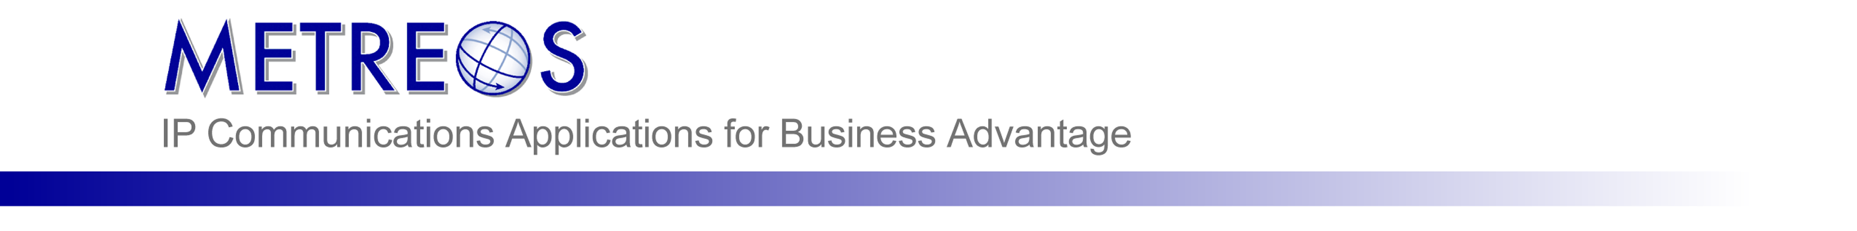

Metreos RemoteAgent ®
A Metreos Technology White Paper


Executive Summary
An important limitation existing in Cisco CallManager-integrated IPCC solutions is that each agent must have a Cisco IP Phone due to the way IPCC monitors the agent’s activity.

Metreos RemoteAgent is the solution which removes this limitation. The Metreos platform, running RemoteAgent, can masquerade as a Cisco IP Phone and receive calls originating from IPCC bound to a particular agent. After determining to which agent the inbound call is destined, a second call is placed to the agent’s Find Me number. The two calls are then bridged using the Metreos Media Engine.

With Metreos RemoteAgent, agents now have the freedom to work at any location having access to the PSTN and to the agent desktop.

This means that RemoteAgent provides call center agents with markedly increased mobility by enabling them to work from virtually any location. Whether it be the case that an agent is ill and contagious but can still work, or that the agent is a valued member of the call center simply requiring the freedom to work from home, RemoteAgent is the ideal way to let them do so.

A related and frequent use of RemoteAgent is that of bridging the gap to greenfield or brownfield sites not having yet converted to VoIP/CallManager/IPCC.

RemoteAgent Overview

What is RemoteAgent?
RemoteAgent is a Metreos platform application that can receive a call from IPCC, determine which call center agent the call is destined for, place another call to the agent’s Find Me number, and finally bridge the two calls together. Because the agent can configure as their Find Me number any destination accessible by the CallManager involved in the call flow, agents are no longer bound to an IP phone when performing call center activities.

Supervisory features are also included in RemoteAgent. At any time a supervisor can dial into the RemoteAgent application to monitor individual extensions and optionally record the current phone call.

How does RemoteAgent Work?
The Metreos Communications Environment (MCE) is capable of leveraging a number of call control protocols, such as CTI, H.323, SCCP, and SIP.

The RemoteAgent application, because it runs in the context of the MCE, can be configured to use any of these protocols when accepting the inbound call, and when placing the call to the agent’s Find Me number.

In practice, a RemoteAgent deployment utilizes the ability of the MCE to virtualize SCCP devices, due to the fact that IPCC can place calls only to SCCP devices. Once such virtual devices are created, each SCCP device is then provisioned for a specific user of RemoteAgent. Each user of RemoteAgent, armed with the knowledge of the extension configured for him or her on the virtual SCCP phone, can now supply this extension to IPCC when logging in through the agent desktop.

The outbound call, the leg placed to the agent’s Find Me number, has no such associated IPCC limitation. Often H.323 will be chosen as the outbound protocol since it is the only protocol able to preserve caller ID. When considerations other than Caller ID are more pressing for the individual deployment, other protocols can certainly be used for the outbound leg. For example, integration to existing CDR analysis and reporting programs could mandate that SCCP be used as the outbound protocol.
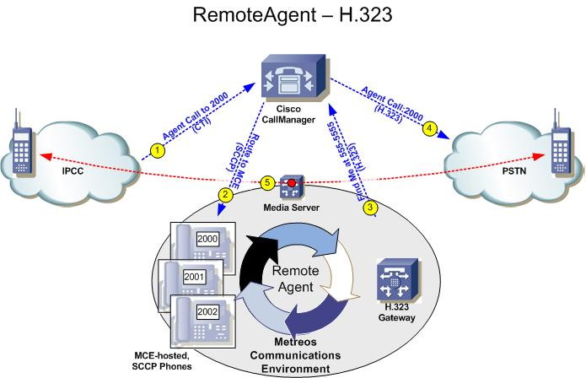
Figure 1: RemoteAgent Call Flow with H.323 Used for the Find Me Call

Understanding the RemoteAgent Call and Media Flow
In the ensuing discussion, please refer to Figures 1 and 2 for illustrations of RemoteAgent call flows when bridging between the IPCC call and the agent’s Find Me number.

Step 1
IPCC originates a call to CallManager via CTI. This is the method by which IPCC integrates into CallManager, and by which it connects calls from customers in the IVR queue to agents. Note that the customer call leg is not illustrated.

Step 2
CallManager routes the call to a virtual SCCP phone. The phone, having already been configured and associated with a specific agent, has associated with it a well-known line number that the agent has previously supplied as their current extension when logging into the agent desktop.

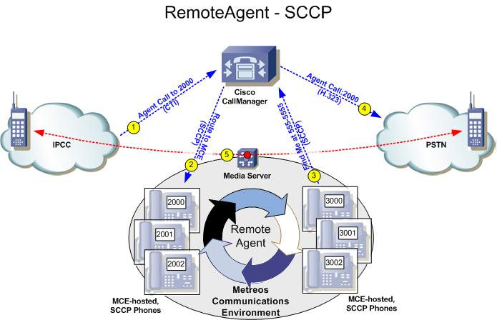
Figure 2: RemoteAgent Call Flow with SCCP Used for the Find Me Call

Step 3
The Metreos Communications Environment, recognizing the triggering criteria for its RemoteAgent configuration, initiates the RemoteAgent application. RemoteAgent places a call to the user’s configured Find Me number on the CallManager, using H.323 (Figure 1), or SCCP (Figure 2).

Step 4
CallManager routes the Find Me call to the agent’s device, presumably, but certainly not restricted to, a location on the PSTN.

Step 5
The agent Find Me phone and the customer IPCC call have their media bridged through the Metreos Media Server. The bridged call is now completely in the domain of the RemoteAgent application, making it very straightforward for the RemoteAgent application to leverage other powerful platform capabilities to expose features such as the supervisor silent monitor and ad-hoc recording.

Agent Self-Administrative Features
Agents can configure their Find Me number in their account profile found in the Application Suite Administrative web interface, as shown in Figure 3.

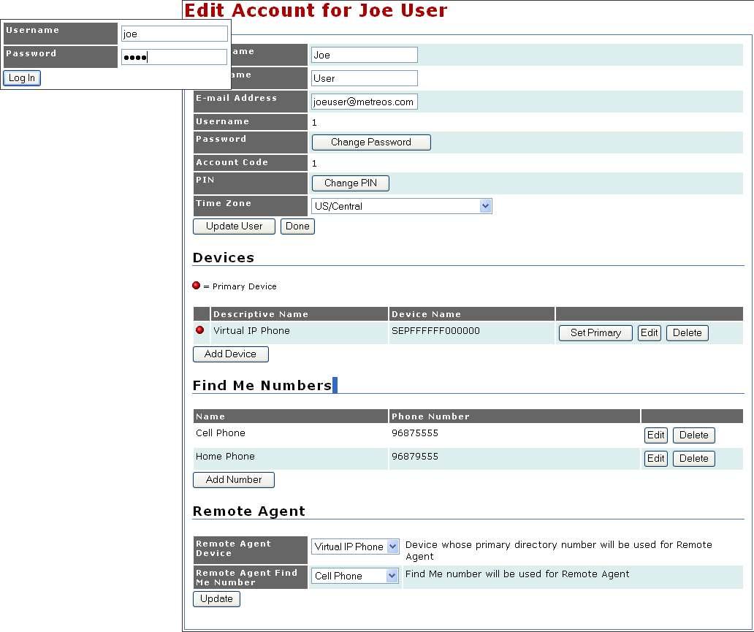
Figure 3: The Agent Account Profile Page

The agent can also look up his or her virtual SCCP device extension from their web-accessible account profile, as shown in Figure 4.

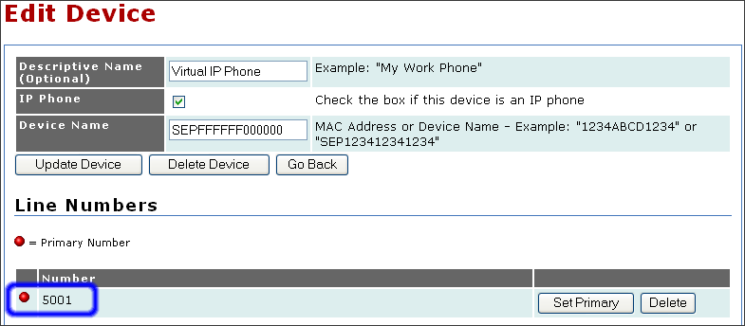
Figure 4: Confirming Virtual Device Extension

Supervisory Features – Silent Monitor and Recording
A supervisor can, at any time, dial into the RemoteAgent application and choose an extension in real time to monitor silently. Once monitoring, the supervisor can initiate ad-hoc recording of a conversation. Recordings are stored on the Metreos Server, available for download from the Application Suite Administrative web interface for easy access and playback. Long-term storage of recordings, if desired, is left to the RemoteAgent deployment. For instance, one solution might be to configure an existing storage mechanism to periodically offload all recordings from the MCE-2400.

RemoteAgent Deployment Considerations
There are a few common factors to keep in mind when considering the ramifications and intricacies of a particular RemoteAgent deployment. These factors, listed below, illustrate the types of requirements, constraints, and metrics which are highly useful in determining the parameters of the deployment and when discussing your tailored solution with the Metreos team. Armed with information such as that described below, you and the Metreos team can accurately size your deployment to the optimal mix of Metreos Communications Application engines and Media engines.

Number of Agents, Concurrent Calls, and BHCA
The Metreos Application Engine and Metreos Media Engine can be co-located on one MCE-2400 server when practical to do so. In such a configuration, the following performance metrics are possible:
- 1500 registered virtual SCCP devices
- 20,000 total BHCA
- 240 concurrent media connections

For RemoteAgent, this means one MCE-2400 can have configured 1500 RemoteAgent users, support 10,000 BHCA incoming from IPCC (since another 10,000 BHCA is generated by the outbound Find Me call leg), and support 120 concurrent RemoteAgent calls (2 media connections per RemoteAgent bridge). Again, there may be additional factors unique to a particular deployment which can alter these numbers, but, in general these figures provide a good basis to work from.

Additional Application and/or Media Engines can of course be easily added to a Metreos cluster in the event that more call or media processing capabilities are needed.

Follow the Media
In a deployment scenario in which the customer has exactly one call center, all customer calls arrive via the PSTN to IPCC, that same gateway is used by RemoteAgent to call out to Find Me numbers, and the Metreos Media Engine is located on the same LAN segment; then there should normally be no bandwidth or other QoS concerns for the deployment.

However, assume the customer has multiple call centers, integrated with various CallManager clusters, and all call centers are separated by WAN links. There is technically nothing that prohibits the RemoteAgent solution from providing all functionality previously described with a single MCE-2400, given that the capabilities of the server can handle the desired load. However, an important exercise should be undertaken before making the assumption that the one MCE-2400 can service all locations, and that is to follow the media.

Since a Metreos Media Engine actively bridges the media of both parties in the call, you must consider where both endpoints of the call are located. For instance, say the PSTN gateway servicing both the inbound and outbound IPCC calls is separated by a WAN link from the Metreos Media Engine. In such a case, the media streams for both call legs to and from the Metreos Media Server are traversing the WAN link, which may or may not be acceptable. If the WAN link does not have the necessary capacity, or may otherwise not be appropriate for carrying the additional media traffic generated by RemoteAgent, a better solution is to provision another Metreos Media Engine to reside in the LAN of the PSTN gateways handling the calls. The Metreos Application Engine, hosting the RemoteAgent application and handling call processing, controls the Metreos Media Engine from afar, with minimal impact to the WAN.

Variations of the above scenario will usually be clarified with the same idea: follow the media of the calls and determine whether the impact on the WAN suggests a need for additional distributed Metreos Media Engines.

In Summary …
RemoteAgent is a simple, yet robust, solution for extending the IPCC agent beyond the IP Phone, offering agents a straightforward web interface with which to configure and maintain their own remote extensions. Additional features, such as silent monitoring and ad-hoc recording are valuable additional capabilities of the solution.

Future enhancements to RemoteAgent can leverage the proven, scalable IPT technology of the Metreos Communications Environment, in order that feature requirements unique to a particular deployment can be easily and quickly incorporated. The flexibility of the application combined with the power of the platform make RemoteAgent an ideal solution.

SIP support will become available second quarter 2006, concurrent with support for CallManager 5.

